Name
Professor’s Name
Course
Date
Understanding Visual Arts
In the book Understanding Visual Arts by Debra J. Dewitte, M. Kathyrn Shields, and Ralph Larman, we have the artwork The Ambassadors, also known as Jean de Dinteille and Georges de Selve by Hans Holbein the Younger, who was a German national. Hans lived mostly in England, and in his work, he showed Early Netherlandish painters influence. The influence is mostly seen when the artist used oil paint. He used quite a lot of imagery to link his work to religious factors. In his painting, he uses objects that simplify interests and secular ideas about religion. Hans did the painting during the Tudor period. This was at the same time when Queen Elizabeth the first was born, that is, the year 1533. The Ambassadors painting medium is oil on oak, and it's a 207 by 209.5 cm painting in size. The painting is among the paintings collection in London's National Gallery (Foister n.p). Several scholars have argued that Hans’ painting contains many things about religious strife. Among them is Jean de Dinteville a landowner and Georges de Selve who is a Bishop in Lavaur. Hans' painting is regarded as one of the most impressive art pieces in the history of renaissance art.
The image of The Ambassadors painting
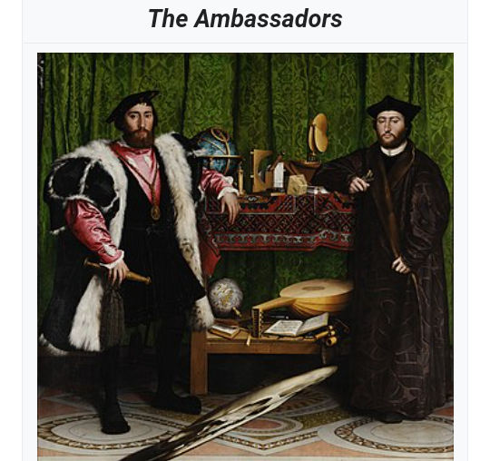
The most evident symbol in the painting is the two men. On the left is Jean de Dinteville and on the right is Georges de Selve. Jean served as a French ambassador to King Henry the eight in his court. Georges was a Bishop in Lavaur. Jean and Georges were great friends and were also regarded as men of reputable character. They were both young and sought to bridge the gap during the time of divisions in the church since King Henry wanted to break away from the church, and the Lutheran church was carrying out reforms all over England. Through the painting, Hans appreciates the two young men and their critical role in England's political and religious affairs (Constantinou 19). The artist displays several prestigious objects to show the influence, the wealth, and how learned the two men were on the tables.
The images of the two men in the painting
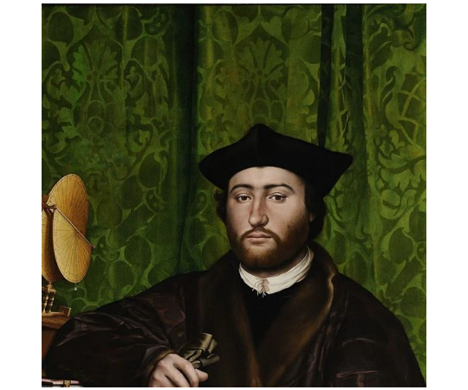
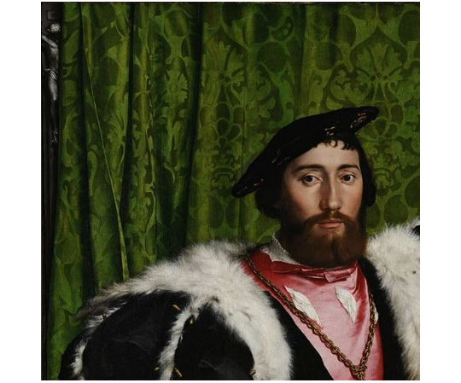

Also, incorporated in The Ambassadors painting, we have two globes. One of the globes is terrestrial, which is on the table, and the other is celestial, which appears under the table (Dekker 44). The terrestrial globe is the standard globe the earth uses. The globe is rotated to approximately 217 degrees clockwise. In the terrestrial globe on the lower shelf, we have a part of an imaginative map that was possibly created in the year 1530, and its origin is not known. The terrestrial globe symbolizes the chaos that came with the church's reformations by Luther.
In contrast, the celestial, which shows the stars' path, symbolizes the heavenly power spheres held over the earth. The map's appearance in the painting has led it to be referred to as the Ambassador's globe. The artist generally uses the globes to show our movements and how we live on earth under heavenly powers.
The images of the two globes
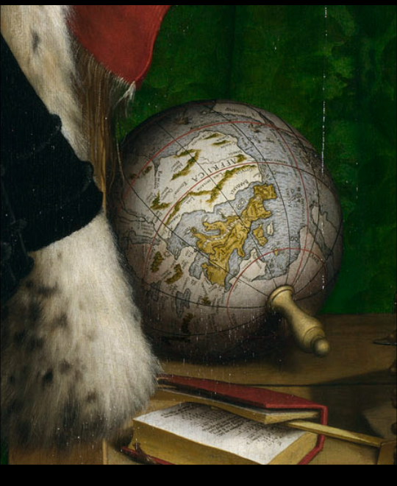
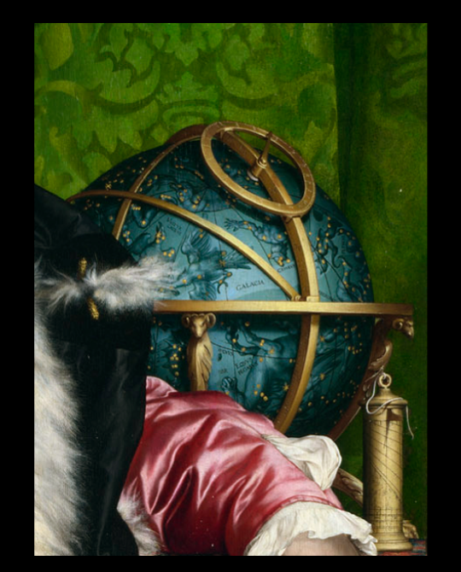
Another symbol that Hans has in his painting is the distorted skull. The skull is the most famous symbol in the painting (Kenaan 64). The skull is in the bottom center of the painting. It is not clear to scholars as to why Hans gave the skull prominence in his painting. However, some scholars think that it represents the heavens evidenced by the objects he shows on the upper shelf, death evidenced by the skull and the living world through a musical instrument and books. Hans presented the skull in an anamorphic perspective, which was an invention of the early renaissance. The anamorphic perspective creates a visual puzzle for the viewer to look at the painting from the right angle to see it as a representation of a human skull. Some scholars think that the painting was intended to be placed in a stairwell. This means that passing the stairwell would be able to see the skull more evidently, and of course, this would spark more interest in the painting.
The image of the skull
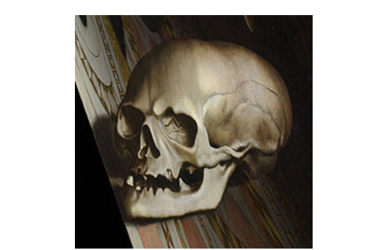
In the painting, we also have the symbol of a crucifix. The crucifix appears in the upper left corner of the painting. A green curtain partially covers it. The green curtain is alluded to be the temple curtain that tore into two during the crucifying of Jesus on the cross; however, the one in the painting is not torn into two. The artist used the skull to portray thoughts of one's inevitable death and their resurrection thereof, while some scholars think it also portrays the divisions that were present in the church in the period he made the painting (Latour 28). Hans shows the world that we have an afterlife through Christ after one has died.
The image of the crucifix
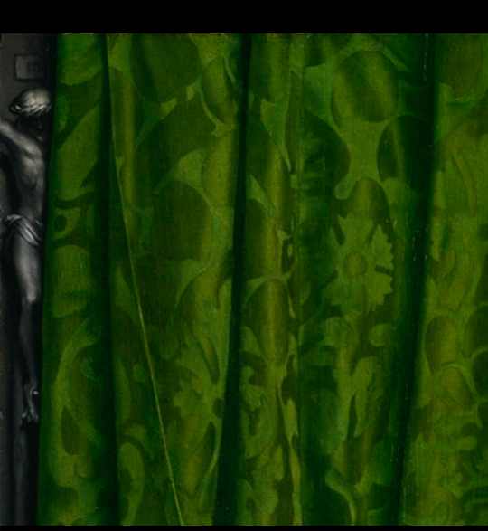
The artist displays musical instruments under the table. One can see a lute that is made of eleven strings and a music book. The lute has a broken string, which scholars of art suggest that it shows the church's disharmony during the Lutheran reformation. It is said that the music book in the painting is a Lutheran hymnal and the hymns are a composition of Luther (Foister n.p). Scholars suggest that the inclusion of the Lutheran hymnal was meant to spark religious debate over the reformations taking place all over England.
The image of the lute and the Lutheran hymnal
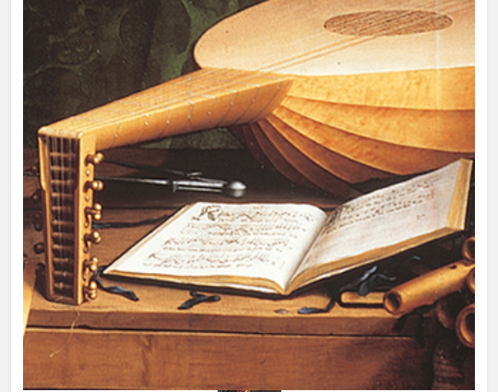
The artist places a polyhedral sundial immediately on the right elbow of the Bishop (Foister n.p). The polyhedral sundial is considered to be a scientific instrument and has various different faces. It has astronomical symbolism of the painting. The artist uses it to show man's many trials to make sense of what life, death, and the universe is. The polyhedral sundial has an irregular shape. The artist compares it to how irregular life is and how man strives to make it in life through irregularities. The whole painting is complex, and one has to do keen and thorough research to comprehend every single part and symbol of it. Scholars, however, in the recent past, have done their best to decode it. The ambassadors painting is one of the greatest and intricate paintings ever known to men, and the artist has acquired global recognition for it among his many other pieces of art.
The image of the polyhedral sundial
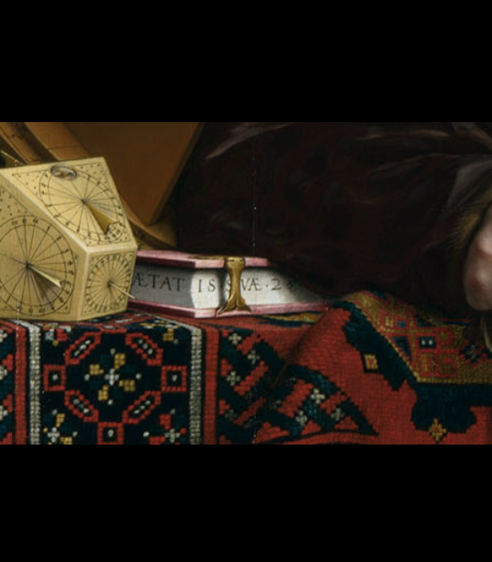

Works Cited
Constantinou, Costas. “Diplomatic Representations… Who Framed the
Ambassador?” Millenium 23.1 (19940:1-23.
Dekker, Elly, and Rudolf Schmidt. “THE GLOBES IN HOLBEIN’S PAINTING”
The Ambassadors”/ DIE GLOBEN AUF HOLBEIN’S GEMALDE, Die
Gesandten Der Globusfreund 47/48 (199):19-52.
Foister, Susan, et al. Holbein’s Ambassadors. London: National Gallery
Publications. 1997.
Kenaan, Hagi. “The Unusual Character of Holbein’s” “Ambassadors." Artibus et
Historiae (2002): 61-75.
Latour, Bruno. "Opening one eye while closing the other… a note on some religion.
Paintings.” The Sociological Review 35 (1987): 15-38.

